**FRIO COUNTY COMMISSIONERS COURT MINUTES FOR**

**Regular Meeting May 29th, 2024**

On the 29th day of May, 2024, at 3:00 p.m., the Commissioners Court of Frio County met in a regular meeting with the following members either absent or present, to-wit: Rochelle Lozano Camacho, Frio County Judge was absent; Joe Vela, Commissioner Pct 1 absent; Mario Martinez, Commissioner Pct 2 present; Raul Carrizales, Commissioner Pct 3 absent; Danny Cano, Commissioner Pct 4 present; Joseph A. Sindon, Legal Counsel for Frio County Commissioners Court present; and Aaron Ibarra, Frio County Clerk present when the following meeting was held, to-wit: The meeting can be seen unedited and to its full extent on our county website, under the County Clerk tab.

I. Invocation and Pledge of Allegiance

II. Adopt Agenda

**MOTION: COMMISSIONER MARTINEZ**

**SECOND: COMMISSIONER CANO**

III. Old Business

**PRESENTATION**

**ACTION AGENDA ITEMS**

IV. General Discussion

V. Citizens To Be Heard

VI. New Business

**PRESENTATION**

(1) Frio County Commissioners Court, requests:

Presentation of monthly statistics reports compiled by Allegiance.

**ACTION AGENDA ITEMS**

(1) Hon. Aaron Ibarra, Frio County Clerk, requests:

1.1 Review Frio County Commissioners Court minutes for April 26 and 30, 2024.

1.2 Consider/Approve Frio County Commissioners Court minutes for April 26 and 30, 2024.

**MOTION: COMMISSIONER MARTINEZ**

**SECOND: COMMISSIONER CANO**

**WITH CORRECTIONS, COMMISSIONER 3 WAS PRESENT**

(2) Hon. Mike Morse, Frio County Sheriff, requests:

Consider and act to approve the purchase of FCSO standard-issue rifle-rated body armor for newly hired deputies (2) for $4547.26 utilizing FCSO line item 57207.5315 (uniform expenses).

**MOTION: COMMISSIONER CANO**

**SECOND: COMMISSIONER MARTINEZ**

(3) Hon. Mike Morse, Frio County Sheriff, requests:

Consider and act to approve the auto repair cost estimate #52 to Hilltop Auto Repair for $10,283.75 utilizing the funds provided by the insurance claim for said collision.

**MOTION: COMMISSIONER CANO**

**SECOND: COMMISSIONER MARTINEZ**

(4) Tommy Navarro, Frio County Building Maintenance Supervisor, requests:

Consider/Take Action on selecting a contractor to demo and install new carpet tile in the District Courtroom located in the Frio Co Courthouse 500 E. San Antonio St, Pearsall, Tx 78061.

**MOTION: COMMISSIONER MARTINEZ**

**SECOND: COMMISSIONER CANO**

(5) Tommy Navarro, Frio County Building Maintenance Supervisor, requests:

Consider / take action on opening bids received by the specified deadline for irrigation systems for the Frio County Courthouse and property.

**NO ACTION TAKEN**

(6) Ancelmo Ornelas, Frio County Road and Bridge Administrator, requests:

6.1 Consider/take action on approving and a permit to Moore Water Supply, to lay, construct and maintain 2” waterline in the right-of-way of CR 1643 by trenching.   Total permit fee $150.00

6.2 If the permit is approved, consider/take action on approving and adopting a resolution to authorize Frio County Judge Hon. Rochelle Camacho to sign same on behalf of Frio County.

**MOTION: COMMISSIONER CANO**

**SECOND: COMMISSIONER MARTINEZ**

(7) Ancelmo Ornelas, Frio County Road and Bridge Administrator, requests:

Consider/take action on waiving fee for Dilley ISD ACE Program for a family engagement event in early celebration of Father’s Day on June 13, 2024 from 9:30 A.M-1:30 P.M at the Community Fishing Pavilion.

**MOTION: COMMISSIONER MARTINEZ**

**SECOND: COMMISSIONER CANO**

(8) Hon. Rochelle Camacho, Frio County Judge, requests:

8.1 Consider/take action to approve the exchange of lot 7 in block 20 of the Townsite of Derby, which is owned by Frio County for lot 10 in block 20 of the Townsite of Derby which is owner by Jose M. Maldonado and Gloria Rodriguez, husband and wife.

8.2 If the purchase is approved, consider/take action on approving a Real Estate Contract for the Exchange of Property to initiate the exchange of lots 7 & 10 in Block 20 of the Townsite of Derby between Frio County and Jose M. Maldonado and Gloria Rodriguez. This approval also includes the purchase of title policy insurance for the parcels and costs of closing to be borne by Frio County at Mission Title Abstract & Guaranty Co., Inc.

**MOTION: COMMISSIONER CANO**

**SECOND: COMMISSIONER MARTINEZ**

(9) Hon. Rochelle Camacho, Frio County Judge, requests:

9.1 Consider/take action on approving a Professional Services Agreement between Frio County and H20 Partners, Inc. for the development of a Federal Emergency Management Agency approved Hazard Mitigation Action Plan Update for Frio County.

9.2 If the agreement is approved, consider/take action on approving and adopting a resolution to authorize Frio County Judge Hon. Rochelle Camacho to sign same on behalf of Frio County.

**MOTION: COMMISSIONER MARTINEZ**

**SECOND: COMMISSIONER CANO**

(10) Hon. Rochelle Camacho, Frio County Judge, requests:

10.1 Consider / take action on approving an Interlocal Agreement for the Provision of Ambulance Services and Emergency Medical Services between Frio County, Texas and the Frio County Hospital District.

10.2 If the agreement is approved, consider/take action on approving and adopting a resolution to authorize Frio County Judge Hon. Rochelle Camacho to sign same on behalf of Frio County.

**MOTION: COMMISSIONER CANO**

**SECOND: COMMISSIONER MARTINEZ**

(11) Hon. Crystal Marquez, Frio County Auditor, requests:

Consider/take action on approving the County Road Bonus Form to provide to the Texas General Land Office for monies due Frio County for an oil and gas lease that includes portions of county-owned land under Derby Road.

**MOTION: COMMISSIONER MARTINEZ**

**SECOND: COMMISSIONER CANO**

**RECESS @ 3:50 PM**

**RESUME @ 4:06 PM**

(12) Hon. Crystal Marquez, Frio County Auditor, requests:

12.1 Consider / take action on approving Security Light Agreement with Medina Electric for scheduled lighting rate for $16.25 per month at CR 2638 & FM 462 in Bigfoot, Texas.

12.2 If the agreement is approved, consider/take action on approving and adopting a resolution to authorize Frio County Judge Hon. Rochelle Camacho to sign same on behalf of Frio County.

**MOTION: COMMISSIONER MARTINEZ**

**SECOND: COMMISSIONER CANO**

(13) Hon. Crystal Marquez, Frio County Auditor, requests:

13.1 Consider / take action on approving the CIAC agreement with American Electric Power Texas (A.E.P), and installation costs of $71.36 to install one 122-watt LED streetlight at CR 2627 & Interstate 35 Frontage Road in Moore, Texas.

13.2 If the agreement is approved, consider/take action on approving and adopting a resolution to authorize Frio County Judge Hon. Rochelle Camacho to sign same on behalf of Frio County.

**MOTION: COMMISSIONER MARTINEZ**

**SECOND: COMMISSIONER CANO**

(14) Hon. Crystal Marquez, Frio County Auditor, requests:

Consider / take action on running a sealed bids ad (below) in the Frio Nueces Current once a week for two weeks pursuant to Local Government Code Sec. 262.025.  The ad will run in the Frio-Nueces Current on May 30, 2024 and June 6, 2024.  Sealed Bids will be accepted in the Auditor’s office until 3:00 pm, June 21, 2024.  Bid’s will be opened during commissioner’s court on June 25, 2024.

**MOTION: COMMISSIONER MARTINEZ**

**SECOND: COMMISSIONER CANO**

**NOTICE**

By order of the Commissioner’s Court of Frio County, Texas, and pursuant to Section 262.023 of the Texas Local Government Code, sealed requests for bids for the completion of Bridge and Approach Replacement Project for bridges located on CR 2410/ San Miguel Rd. and CR 3314/ E. Goldfinch Rd., will be received at the Frio County Auditor’s Office located at 500 E. San Antonio St. Ste 3, Pearsall, Texas 78061 until **3:00 P.M., June 21, 2024**. Bids received after the time indicated will be returned unopened. The bids will be opened and read aloud during the Commissioner’s Court meeting on **June 25, 2024**. Prospective bidders may contact Crystal Marquez, 500 E. San Antonio St. Ste. 3, Pearsall, Texas 78061; phone 830-505-2983; or by e-mail at [crystal.marquez@friocounty.org](mailto:crystal.marquez@friocounty.org) in regards to obtaining bidding documents. An appointment to inspect the project may be scheduled by contacting Miss Marquez. Frio County reserves the right to reject any and all bids and to accept the bid most advantageous to the County. For more information, visit <https://www.co.frio.tx.us/page/frio.BidNotices>.

(15) Hon. Crystal Marquez, Frio County Auditor, requests:

Consider / take action on approving quote #2634222 from Motorola Solutions to purchase one APX4500 VHF Enhanced Mobile, 5-year essential service, including accessories to be utilized by the Frio County Constable Pct. 1, for a total cost of $3,921.26. This purchase will be paid out of line item 100/57101.5220.

**MOTION: COMMISSIONER CANO**

**SECOND: COMMISSIONER MARTINEZ**

(16) Hon. Crystal Marquez, Frio County Auditor, requests:

16.1 Consider / take action on approving credit application and sales agreement with Pico Propane and Fuels for the Frio County Road & Bridge Department.

16.2 If the agreement is approved, consider/take action on approving and adopting a resolution to authorize Frio County Judge Hon. Rochelle Camacho to sign same on behalf of Frio County.

**MOTION: COMMISSIONER CANO**

**SECOND: COMMISSIONER MARTINEZ**

(17) Hon. Crystal Marquez, Frio County Auditor, requests:

Present Frio County Jail Commissary Fund Audit. A copy of the Commissary Audit will be provided to Texas Commission on Jail Standards.

**MOTION: COMMISSIONER CANO**

**SECOND: COMMISSIONER MARTINEZ**

(18) Hon. Crystal Marquez, Frio County Auditor, requests:

Consider / take action on closing the following bank accounts and transferring bank balances into the Disbursement Fund bank account. Justice of the Peace Pct. 2 Escrow, Hot Check, Cemetery Perpetual, and Interest & Sinking.

**MOTION: COMMISSIONER MARTINEZ**

**SECOND: COMMISSIONER CANO**

(19) Hon. Crystal Marquez, Frio County Auditor, requests:

Discuss request for proposals (RFP) for insurance coverage for public officials liability; law enforcement liability; general liability; automobile liability; auto physical damage (Collision/Comprehensive); crime; cyber liability; property, to include: buildings and contents, equipment breakdown, mobile equipment, electronic data, media and hardware, for fiscal year 2024-2025.

**NO ACTION TAKEN**

(20) Hon. Crystal Marquez, Frio County Auditor, requests:

20.1 Consider / take action to approve the budget amendments to the FISCAL YEAR 2023-2024 Frio County Budget, list below:

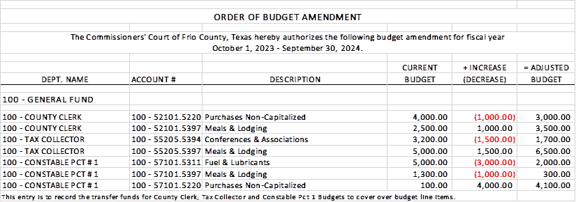

20.2 If the amendment is approved, consider/take action on signing order stating same.

**MOTION: COMMISSIONER CANO**

**SECOND: COMMISSIONER MARTINEZ**

(21) Hon. Crystal Marquez, Frio County Auditor, requests:

21.1 Consider / take action to approve the budget amendments to the FISCAL YEAR 2023-2024 Frio County Budget, list below:

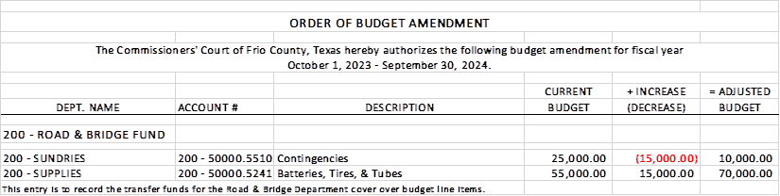

21.2 If the amendment is approved, consider/take action on signing order stating same.

**MOTION: COMMISSIONER CANO**

**SECOND: COMMISSIONER MARTINEZ**

(22) Hon. Crystal Marquez, Frio County Auditor, requests:

22.1 Consider / take action to approve the budget amendments to the FISCAL YEAR 2023-2024 Frio County Budget, list below:

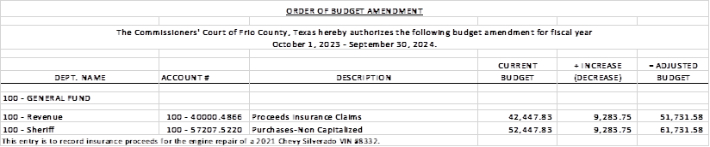

22.2 If the amendment is approved, consider/take action on signing order stating same.

**MOTION: COMMISSIONER MARTINEZ**

**SECOND: COMMISSIONER CANO**

(23) Hon. Crystal Marquez, Frio County Auditor, requests:

23.1 Consider / take action to approve the budget amendments to the FISCAL YEAR 2023-2024 Frio County Budget, list below:

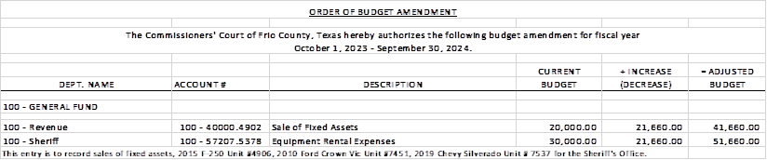

23.2 If the amendment is approved, consider/take action on signing order stating same.

**MOTION: COMMISSIONER CANO**

**SECOND: COMMISSIONER MARTINEZ**

(24) Hon. Crystal Marquez, Frio County Auditor, requests:

Discuss and/or take appropriate action to certify the revenue received, $9,283.75 under the General Fund (fund 100) and add the following line items to the 2023-2024 Budget to receipt the funds and allow expenses:

Account #: **100-40000.4866** PROCEEDS INSURANCE CLAIMS

Account Name: REVENUES

Account #: **100-57207.5220** PURCHASES NON-CAPITALIZED

Account Name: SHERIFF

**MOTION: COMMISSIONER MARTINEZ**

**SECOND: COMMISSIONER CANO**

(25) Hon. Crystal Marquez, Frio County Auditor, requests:

Discuss and/or take appropriate action to certify the revenue received, $21,660.00 under the General Fund (fund 100) and add the following line items to the 2023-2024 Budget to receipt the funds and allow expenses:

Account #: **100-40000.4902** SALES OF FIXED ASSETS

Account Name: REVENUES

Account #: **100-57207.5378** EQUIPMENT RENTAL EXPENSES

Account Name: SHERIF

**MOTION: COMMISSIONER CANO**

**SECOND: COMMISSIONER MARTINEZ**

(26) Ray Baca, P.E., RL Baca Engineering, requests:

Consider / take action on running a Legal Notice regarding a proposed subdivision plat revision (below) in the Frio Nueces Current once a week for three weeks pursuant to Local Government Code Sec. 232.009.  The notice will run in the Frio-Nueces Current on June 6, 2024, June 13, 2024, and June 20, 2024.  A Public hearing regarding the plat revision will be held during commissioner’s court on July 9, 2024.

**LEGAL NOTICE**

This notice is to make public the request to revise the subdivision plat to remove lots 13, 14, and 15 of the Zamora CR 2400 Subdivision, Frio County, Texas, as shown by Plat recorded on Side 1, Sheet 172A of the Plat Records of Frio County, Texas.

It has been proposed that Lots 13, 14, and 15 of the plat be returned to raw unplatted and unsubdivided land. The plat revision is proposed by Alfredo Zamora, Jr. (owner). The hearing for consideration of this application will be held on July 9, 2024, at 3:00 p.m., at a regular meeting of the Frio County Commissioners Court, located at the Frio County Courtroom of the Frio County Courthouse at 500 E. San Antonio St., Pearsall, Texas 78061.

**MOTION: COMMISSIONER CANO**

**SECOND: COMMISSIONER MARTINEZ**

(27) Documents (resolutions, orders, contracts, etc.) to be signed.

(28) Allow bills payable

**MOTION: COMMISSIONER CARRIZALES**

**SECOND: COMMISSIONER MARTINEZ**

**WITH COMMISSIONER 2 MARTINEZ ABSTANING FROM PAGE 4**

(29) Adjourn

**MOTION: COMMISSIONER CARRIZALES**

**SECOND: COMMISSIONER MARTINEZ**